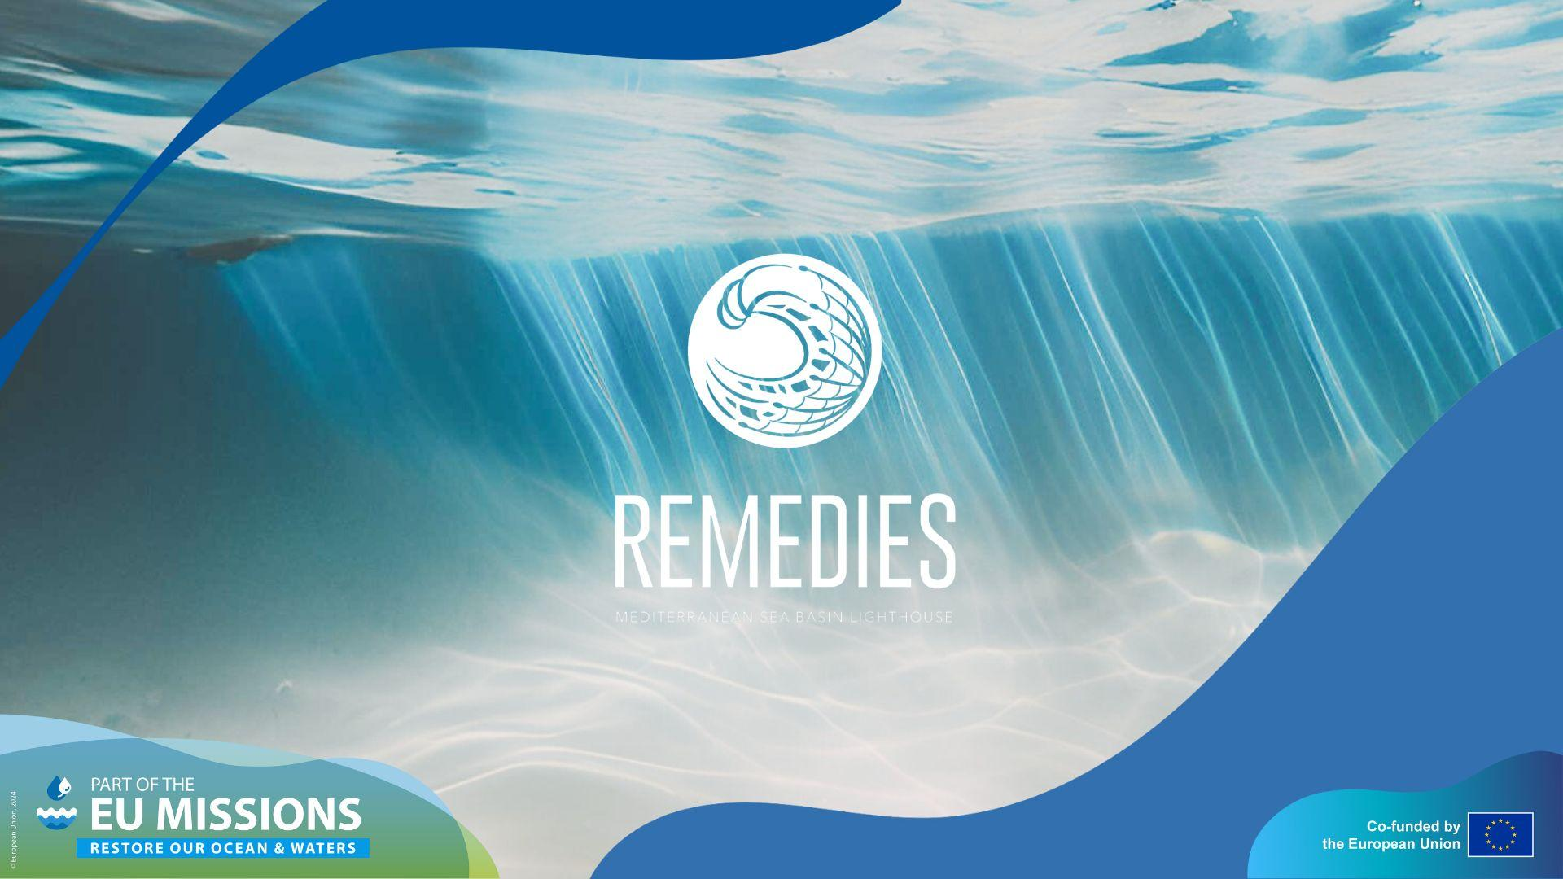

Remedies Citizen Science App Guideline
This user manual provides clear, step-by-step instructions on how to use the REMEDIES Citizen Science App. It guides coordinators and participants through the full process, from downloading the app and managing clean-up campaigns to submitting litter data and reporting results. Screenshots should be included for each step to enhance understanding.

Roles Involved in the application 2
1. Campaign Creator / Organizer 2
2. Coordinator 2
3. Participant 2
Step1: Download the App 2
Step2: Login to the Portal 3
Step3: Create a new Campaign 4
Step4: Add Groups and Assign Coordinators 5
Step5: Coordinator Login or Signup 5
Step6: Manage Groups As Coordinator 6
Step7: Participant Login or Signup 7
Step8: Add Collected Litter 8
Step9: End Cleanup and Upload Photos 9
Step10: Record Bag Weights 9
GDPR And Data Privacy: 11
Support: Contact Us: 12

Roles Involved in the application

1. Campaign Creator / Organizer
- Responsible for setting up new cleanup campaigns.
- Defines the event’s name, date, time, location, and description.
- Creates groups and assigns coordinators to each group.

2. Coordinator
- Assigned to one group by the organizer.
- Manages group data, adds participants, and sets the cleanup timeframe.
- Ends the cleanup session and uploads group photos and bag photos.
- Records the bag weights after the event for accurate statistics.

3. Participant
- Joins a group via signup or login.
- Contributes to data collection by recording collected litter.
- Works together with the coordinator and other participants to ensure accurate reporting.

Step1: Download the App
Download the REMEDIES Citizen App from your device’s official app store (Google Play or Apple App Store). Search for “REMEDIES Citizen” and install it.

Alternatively, scan the QR codes below to download the app instantly.

 | 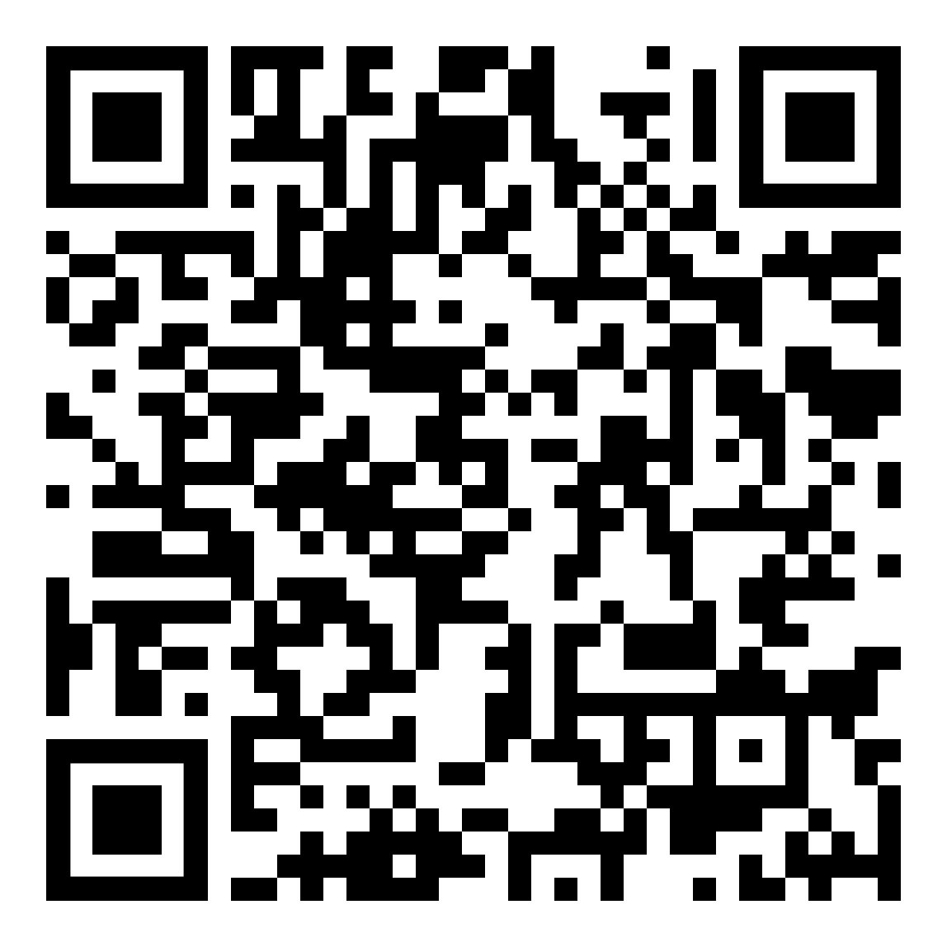
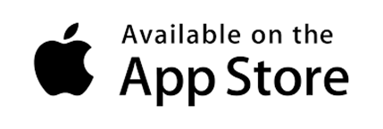 | 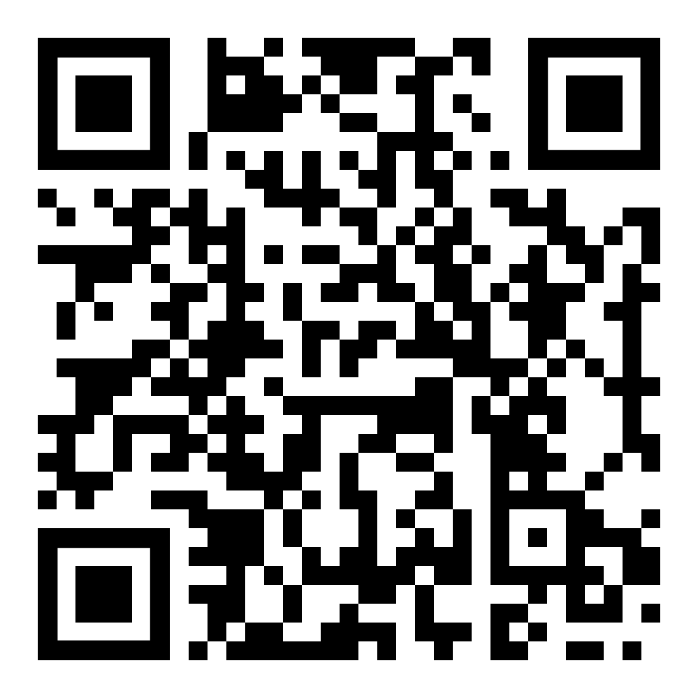

Step2: Login to the Portal
- Visit the online portal: https://remedies.infordata.eu.

- Navigate to Remedies Citizen > Campaign to manage events.

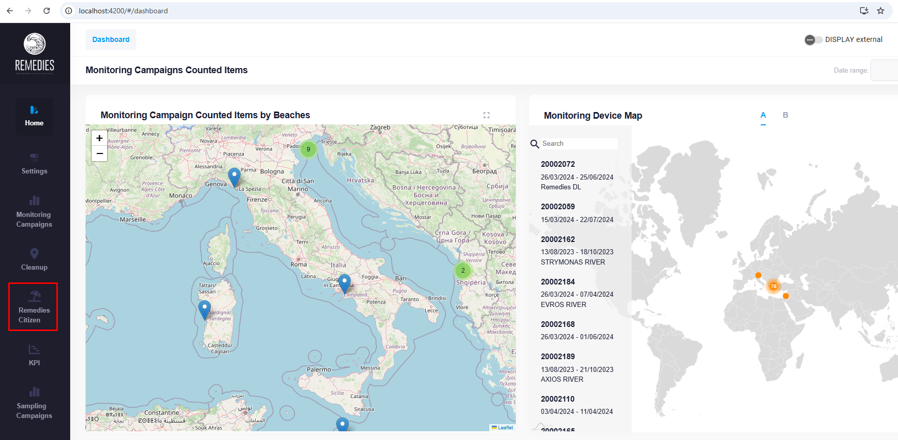

Step3: Create a new Campaign
To begin a new cleanup event:

- Click on “Create Campaign.”
- Fill in the general details such as:
  - Campaign name
  - Date and time
  - Location
  - Description
- Save your campaign.

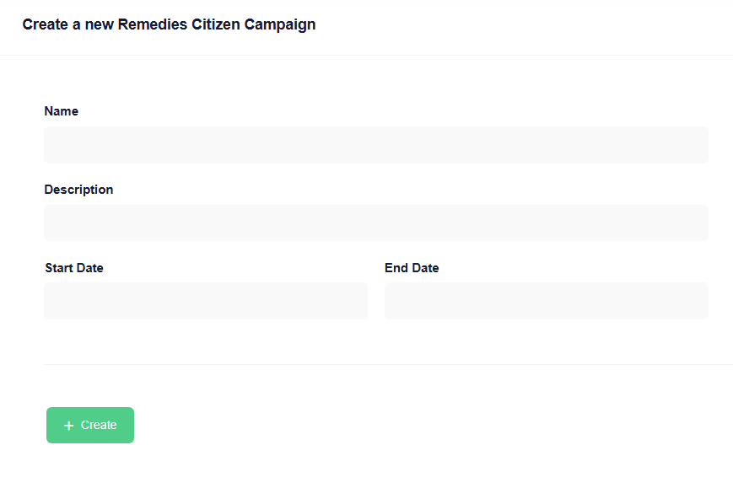

Step4: Add Groups and Assign Coordinators
- Create one or more Groups under your campaign.
- Assign a Coordinator to each group. Coordinator’s email address is required.
Each coordinator will be responsible for managing their assigned group in the field.

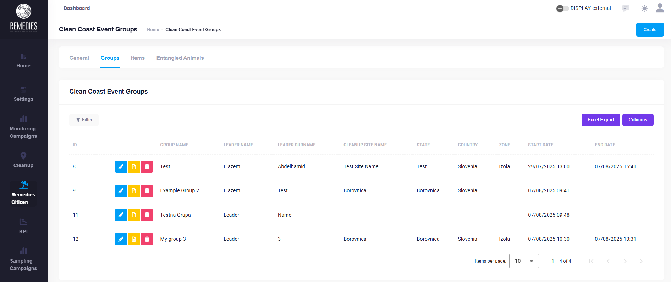

Step5: Coordinator Login or Signup
Coordinators can:
- Log in if they already have an account
- Sign up via the mobile app if they are new users
After logging in, coordinators can manage their group and its activities.

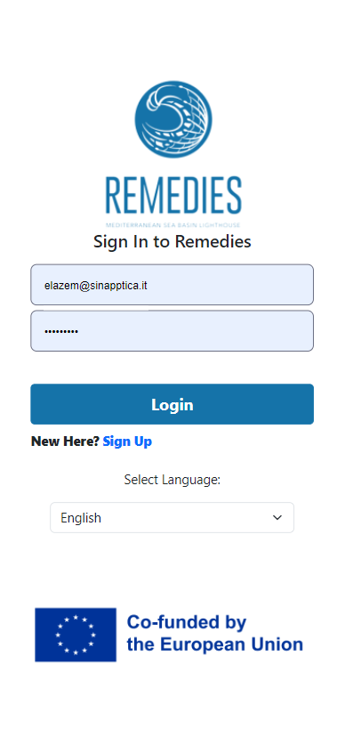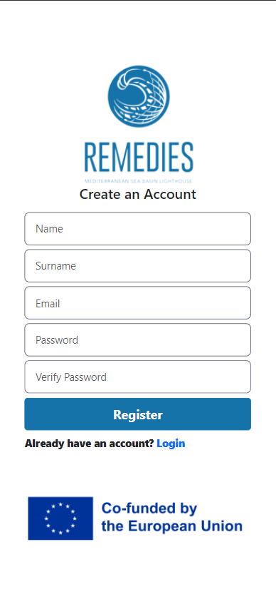
Step6: Manage Groups As Coordinator
Coordinators are responsible for:
- Filling in the group’s general data
- Adding participants
- Setting the start and end times for the cleanup
Only the group coordinator has access to this management functionality.

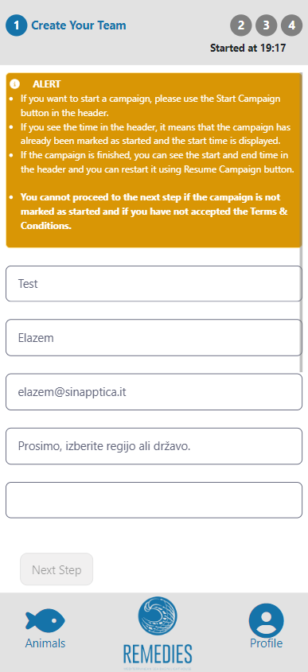
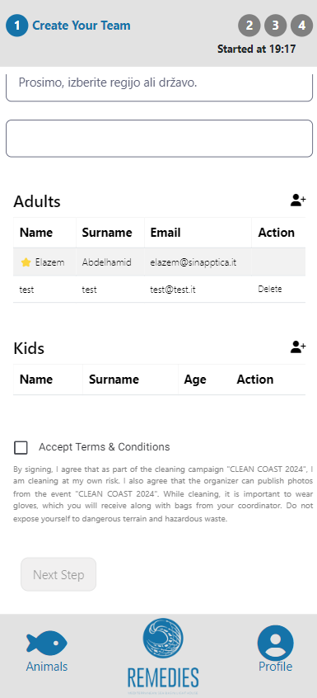

Step7: Participant Login or Signup
Participants can also:
- Log in to their existing account
- Or sign up via the mobile app
Once logged in, participants can join the group and contribute to data collection.

Step8: Add Collected Litter
Both coordinators and participants can:
- Open the app during cleanup
- Add details about the litter collected
- Use the in-app categories for accurate reporting
This helps ensure consistent data for marine litter tracking.
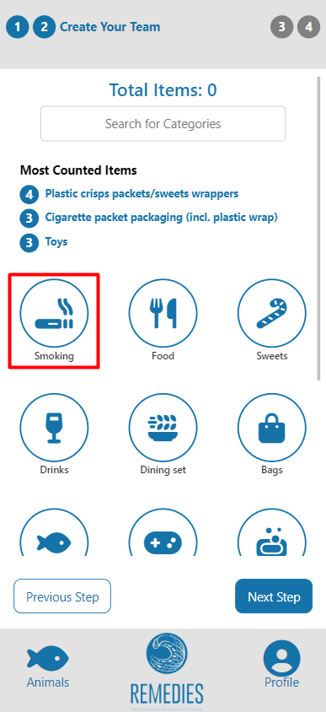
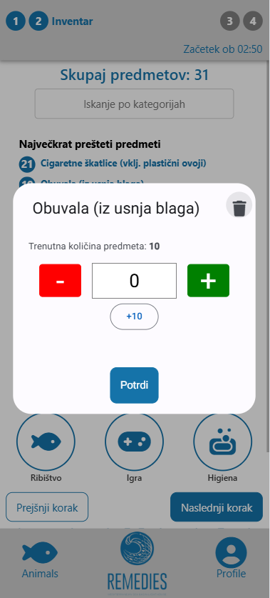
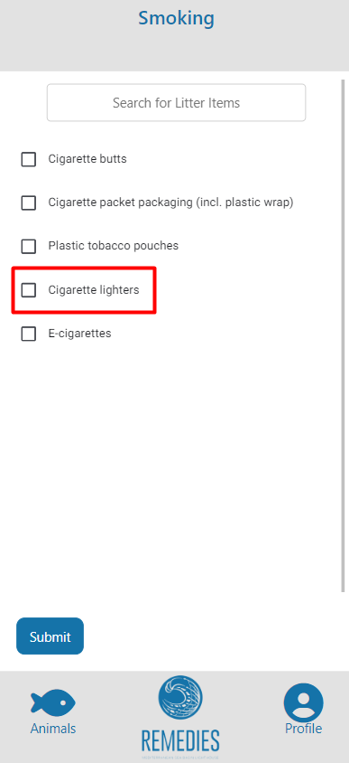

Step9: End Cleanup and Upload Photos
After the cleanup event, you can record the weights of collected bags either from the web portal or directly from the mobile app.

From the Portal:
- Open your campaign from the event list.
- Go to the Groups tab and select the group you wish to update.
- In the Cleanup section, use the Bags Details (per bag) table to record each collected bag:
  - Select the bag type from the dropdown (e.g., 25 L, 45 L, 60 L, 100 L, rubble, fishing gear, etc.).
  - Enter the exact weight in kilograms, as recorded during the event.
The system will automatically calculate and display:
- Total number of bags collected.
- Total collected weight (kg).
- Breakdown of bags by type.

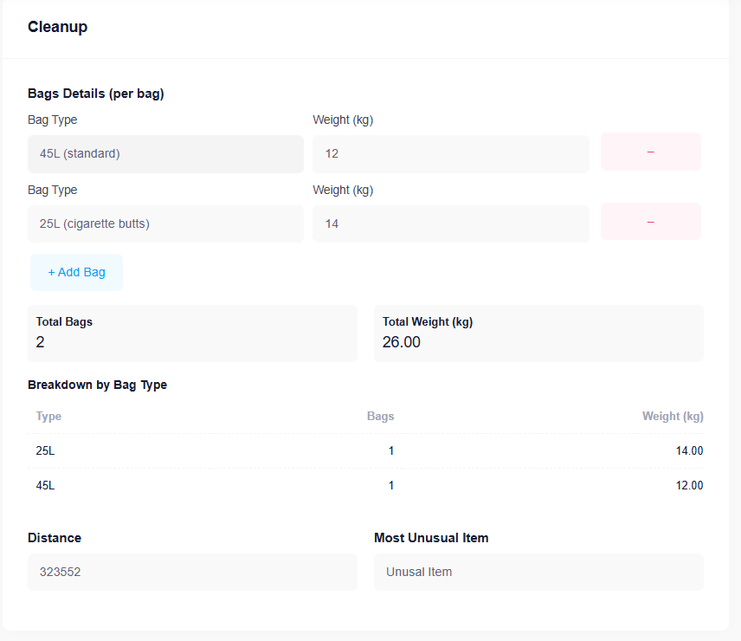

From the Mobile App:
- Open the Čista Obala App on your phone.
- Navigate to your campaign and select the correct Group.
- Tap Cleanup > Manage Bags.
- For each bag:
  - Select the bag type.
  - Enter the recorded weight in kilograms.
  - Save the entry.
- You can also edit or delete bag records directly in the app if mistakes occur.
All data recorded in the mobile app will sync with the central campaign database, and the totals will be updated automatically.
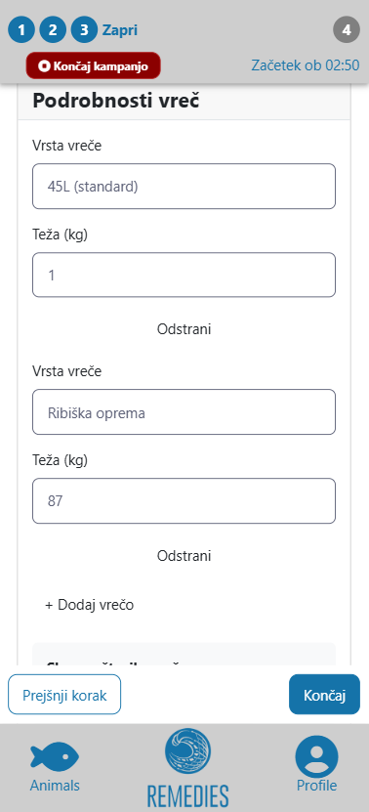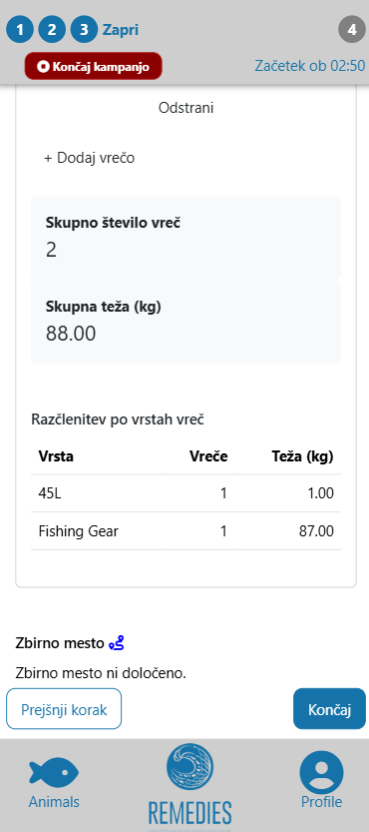

This detailed per-bag recording improves the accuracy of statistical analysis and enhances environmental impact reporting for future campaigns.

GDPR And Data Privacy:
The Undersea Mobile App prioritizes your data privacy, adhering strictly to the principles of the General Data Protection Regulation (GDPR). This commitment encompasses:
- Explicit Consent: Obtaining your express consent for data processing activities.
- Transparent Policies: Providing clear and accessible privacy policies.
- Data Control: Offering robust options for data deletion and anonymization after a specified retention period.
For a comprehensive understanding of our data privacy practices, please refer to our full privacy policy: https://infordata.pro/privacy-policy-for-users-of-infordatas-app/

Support: Contact Us:
Should you encounter any bugs, have questions, or wish to suggest improvements, please do not hesitate to contact the Infordata team directly at https://ticket.infordata.it.

We are here to assist you and value your feedback.

